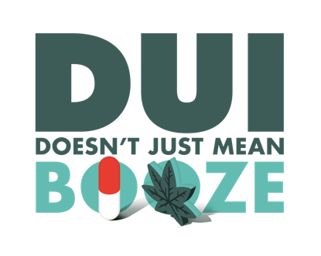
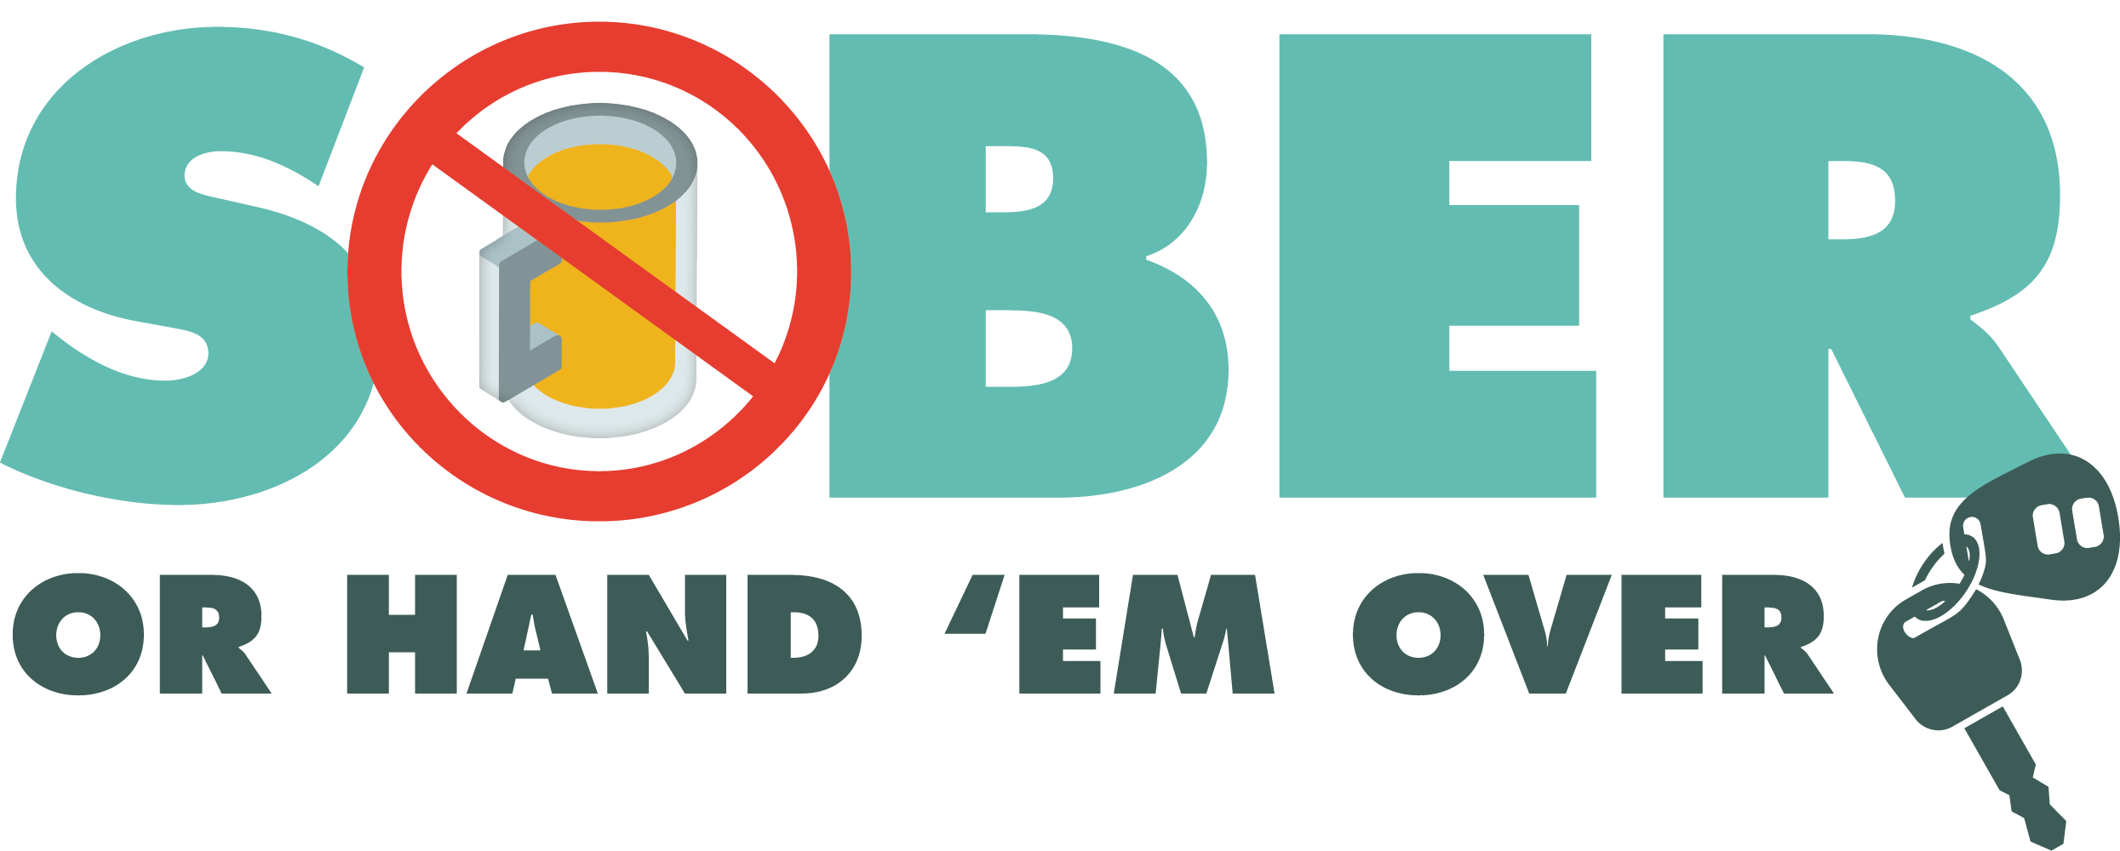
For Immediate Release
August 24, 2023

Contact: Corporal B. Johnson / 714-562-3943 / BJohnson@bppd.com

The Buena Park Police Department is Holding DUI Checkpoint September 15, 2023

Buena Park, Calif. – On September 15, 2023, the Buena Park Police Department will conduct a driving under the influence (DUI) Checkpoint from 7 p.m. to 3 a.m. at an undisclosed location within the city.

DUI checkpoint locations are determined based on data showing incidents of impaired driving-related crashes. The primary purpose of DUI checkpoints are to promote public safety by taking suspected impaired drivers off the road.

“Impaired drivers put others on the road at significant risk,” Corporal Bryan Johnson said. “Any prevention measures that reduce the number of impaired drivers on our roads significantly improves traffic safety.”

The Buena Park Police Department reminds the public that impaired driving is not just from alcohol. Some prescription medications and over-the-counter drugs may interfere with driving. While medicinal and recreational marijuana are legal, driving under the influence of marijuana is illegal.

Drivers charged with a first-time DUI face an average of $13,500 in fines and penalties, as well as a suspended license.

Funding for this program was provided by a grant from the California Office of Traffic Safety, through the National Highway Traffic Safety Administration.

###

